

How to Teach Children Problem-Solving Skills
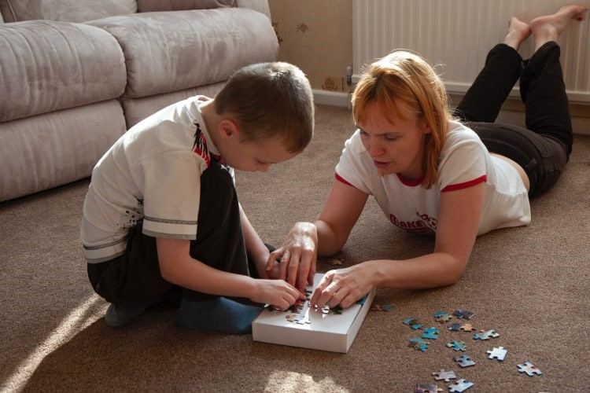
(The following article can be found at www.verywellfamily.com)
Whether your child can't find their math homework or has forgotten their lunch, good problem-solving skills are the key to helping them manage their life.
A 2010 study published in Behaviour Research and Therapy found that kids who lack problem-solving skills may be at a higher risk of depression. Additionally, the researchers found that teaching a child problem-solving skill can improve mental health.
You can begin teaching basic problem-solving skills during preschool and help your child sharpen their skills into high school and beyond.
Why Problem-Solving Skills Matter
Kids face a variety of problems every day, ranging from academic difficulties to problems on the sports field. Yet few of them have a formula for solving those problems.
Kids who lack problem-solving skills may avoid taking action when faced with a problem.
Rather than put their energy into solving the problem, they may invest their time in avoiding the issue.﻿ That's why many kids fall behind in school or struggle to maintain friendships.
Other kids who lack problem-solving skills spring into action without recognizing their choices. A child may hit a peer who cuts in front of them in line because they are not sure what else to do.
Or, they may walk out of class when they are being teased because they can't think of any other ways to make it stop. Those impulsive choices may create even bigger problems in the long run.
The 5 Steps of Problem-Solving
Kids who feel overwhelmed or hopeless often won't attempt to address a problem. But when you give them a clear formula for solving problems, they'll feel more confident in their ability to try. Here are the steps to problem-solving:﻿
- Identify the problem. Just stating the problem out loud can make a big difference for kids who are feeling stuck. Help your child state the problem, such as, "You don't have anyone to play with at recess," or "You aren't sure if you should take the advanced math class."
- Develop at least five possible solutions. Brainstorm possible ways to solve the problem. Emphasize that all the solutions don't necessarily need to be good ideas (at least not at this point). Help your child develop solutions if they are struggling to come up with ideas. Even a silly answer or far-fetched idea is a possible solution. The key is to help them see that with a little creativity, they can find many different potential solutions.
- Identify the pros and cons of each solution. Help your child identify potential positive and negative consequences for each potential solution they identified.
- Pick a solution. Once your child has evaluated the possible positive and negative outcomes, encourage them to pick a solution.
- Test it out. Tell them to try a solution and see what happens. If it doesn't work out, they can always try another solution from the list that they developed in step two.
Practice Solving Problems
When problems arise, don’t rush to solve your child’s problems for them. Instead, help them walk through the problem-solving steps. Offer guidance when they need assistance, but encourage them to solve problems on their own. If they are unable to come up with a solution, step in and help them think of some. But don't automatically tell them what to do.
When you encounter behavioural issues, use a problem-solving approach. Sit down together and say, "You've been having difficulty getting your homework done lately. Let's problem-solve this together." You might still need to offer a consequence for misbehaviour, but make it clear that you're invested in looking for a solution so they can do better next time.
Use a problem-solving approach to help your child become more independent.
If they forgot to pack their soccer cleats for practice, ask, "What can we do to make sure this doesn't happen again?" Let them try to develop some solutions on their own.
Kids often develop creative solutions. So they might say, "I'll write a note and stick it on my door so I'll remember to pack them before I leave," or "I'll pack my bag the night before and I'll keep a checklist to remind me what needs to go in my bag."
Provide plenty of praise when your child practices their problem-solving skills.
Allow for Natural Consequences
Natural consequences may also teach problem-solving skills. So when it's appropriate, allow your child to face the natural consequences of their action. Just make sure it's safe to do so.
For example, let your teenager spend all of their money during the first 10 minutes you're at an amusement park if that's what they want. Then, let them go for the rest of the day without any spending money.
This can lead to a discussion about problem-solving to help them make a better choice next time. Consider these natural consequences as a teachable moment to help work together on problem-solving.

