

Teaching Kids How to Deal with Conflict
The following article can be found at www.childmind.org
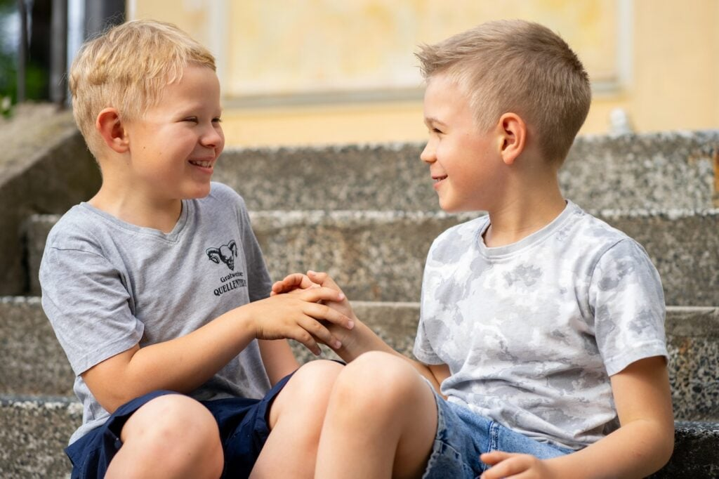
No one likes dealing with conflict. But no matter how hard we try to avoid them, arguments, fights and disagreements are a fact of life — for adults and for kids. And not dealing with conflicts when they arise can negatively impact relationships and lead to further interpersonal challenges down the road.
Conflict may not be pleasant, but it doesn’t have to feel catastrophic. Teaching kids practical skills to manage it in a healthy way will help them navigate everything from small squabbles (“She took my doll!”) to big issues (“I don’t know if I want to be your friend anymore”) both now and as they grow up.
Tackle feelings first
Part of what makes conflicts difficult to navigate is the way they bring out big, intense emotions that children may not have the tools to process. Before they can address the problem that caused the conflict — whether it was a fight over a toy or betrayal by friend — kids need to be able to get to a place emotionally where they can think before they act (or lash out and make things worse).
Parents can start by helping kids identify the emotions they’re having. Are they feeling anger? Frustration? Hurt? Embarrassment? Stephanie Lee, PsyD, a child psychologist, and Carey Werley, LCSW, a clinical social worker at the Child Mind Institute, recommend using visual tools to help little kids identify what they’re feeling.
- Visual feelings chart: Typically, this is a chart showing facial expressions that illustrate different emotions. “You can buy magnetized charts, which are a handy addition to the refrigerator and which help kids identify what they’re feeling,” says Werley.
- The stoplight: A visual red, yellow and green stoplight is especially helpful for little kids. “If a little kid looks at the stoplight and points to the red zone, then the feelings are so big that they’re probably not going to be able to act in a way that’s going to resolve the conflict yet,” says Werley. “Yellow means the intensity of the emotion is beginning to subside and by the time they get to green, they’re going to be able to engage in actual conflict resolution skills. It’s about helping kids to not act in a way that’s going to make the situation bigger or worse.”
- The emotion thermometer: Easily Googleable, the emotion thermometer is simply a picture of a thermometer with numbers. When conflicts come up, kids can look at the emotion thermometer to assess where they are on it. Based on the number, the child can decide whether they need to calm down before proceeding. Tweens and teens who’ve learned these techniques can simply visualize the stoplight or thermometer in their minds in order to assess their emotional state.
When emotions are still intense, it’s not the right time to problem-solve about the conflict itself. Help kids come up with a toolbox of coping skills to use if they need to calm down in the heat of the moment. This might mean splashing cold water on your face, taking some deep breaths or playing with a pet.
Pinpoint the source of the conflict
Once big emotions have cooled down, the next step is figuring out exactly what the problem is. Sometimes kids, especially younger ones, don’t have the emotional awareness to identify the original source of the conflict. They might need your help to understand why they’re fighting. For example, if your child and their friend are squabbling over a toy, the issue might be much deeper, explains Werley. “It could actually be that one of them made a new friend and the other feels left out,” she says.
Helping kids get to the root of the issue will make it easier for them to resolve what’s actually wrong. It will also give them tools to identify and talk about similar problems when they come up again. Older kids starting in grade school and middle school are more likely to have the language to identify the source of the conflict, so with a little guidance they can learn to use these skills independently going forward.
Brainstorm solutions
Once kids understand what the issue is, you can help them practice finding solutions. Little kids in particular will need a grown-up’s guidance here, but even older kids and teenagers can benefit from having someone to bounce ideas of off.
For any age, Dr. Lee suggests brainstorming several solutions then putting your heads together to pick the best one. For younger kids, she recommends a couple of ways to structure this conversation:
- Problem-solving baseball: This exercise takes kids through the processing of thinking up and evaluating possible action plans. “I have kids pitch me a problem and then we go through the bases,” Dr. Lee explains. “So, first base is what’s my problem? Second base is what are some potential options? Third base identifies the best options. And home plate is, am I safe or out? Did I pick the right one? The object is to help even very young kids start to understand what is going to get them closest to their goal.”
- The smiley face rating: Lee suggests asking your child to come up with possible conflict resolution options and then asking, “Is this behavior going to make you feel better or worse or pretty much the same?” Note the answer using a visual rating: smiley face, frowny face, neutral? “And then we look at all of our smiley ratings to help us decide which one is the best option. But also explain to them that it’s not just about how you feel, it’s about whether or not it’s going to help you to reach your goal.”
Of course, the tricky thing here is that it’s usually hard to know what the best option really is. And that’s okay! Let kids know that the goal is to make your best effort, not to solve everything perfectly right away. They might have to go back to the drawing board if their first plan doesn’t pan out — often, that’s just part of the process. “You also want to jump in and praise your child for trying those skills even if things didn’t work out as they had hoped,” says Dr. Lee. “Give them credit and then help them navigate from there. And when they do figure it out, make a big deal out of that.”
Get some perspective
Conflicts often feel enormous and immediate, which can make it hard to keep perspective on the situation. To find useful solutions, it’s important for kids to practice taking a mental step back. A few tips you can encourage kids to keep in mind include:
- Think beyond this one incident. If a close friend tells a secret you trusted them with, it’s natural to be upset. But does that really mean that the friendship is over? Encourage your child to consider the rest of their relationship with the person they’re in conflict with, and remind them that one behavior doesn’t define the entire person.
- Put yourself in the other person’s shoes. “You want to really work on acknowledging what the other person is saying,” says Werley. “even if you don’t totally understand why they’re feeling that way or don’t agree with the way that they’re describing the situation.” Imagining what the other person is feeling is a great way to help kids develop empathy. Depending on the situation, it might also make sense for your child to talk over the issue with the other person and make a point of listening actively — without interrupting. Practicing these skills can help kids resolve conflicts in the short term and become more empathetic in the long term.
- Consider the context. The time and place of the conflict will often dictate how kids respond to it, as will the nature of their relationship to the other person. In particular, Dr. Lee notes that it’s important for kids to know that conflicts with adults will often look different from conflicts with other kids. For example, a child who gets angry with a teacher during class might have to sit with those feelings until it’s possible to set up a private meeting with the teacher. Taking a step back to consider all the dynamics of a situation will set kids up to navigate the conflict more successfully.
Practice effective communication
In order to resolve a conflict, kids need to learn to communicate their feelings clearly, without lashing out or making accusations. It’s tough to practice communication skills when tensions are running high, so consider talking over these skills with kids when they’re not already in the midst of a conflict. Then, you can provide gentle reminders and guidance when things do get heated. Werley and Dr. Lee recommend the following strategies:
- Using “I” statements to name feelings. You’ve heard it before, but it’s still true: Saying something like, “I felt embarrassed when you posted that on Instagram” is usually more helpful than something like, “You posted that picture just to embarrass me!”
- Writing out talking points. “Even if it’s just planning out a conversation in their journal, thinking through what to say ahead of time can help kids get their points across effectively,” says Werley.
- Role-playing with an adult. “Having a safe space to practice tricky conversations can be a huge help,” says Dr. Lee. You can also offer your child insight on nonverbal communication that they might not be aware of — e.g., “What you said was really kind, but I had a harder time appreciating it because you were looking at the ground.”
Model what you want to see
One of the most powerful things you can do to help your child learn conflict resolution is to show them how it’s done. When you experience a conflict of your own (especially one with your child!), put the techniques described here into practice. When appropriate, you can even talk your child through how you solved the conflict. Seeing you succeed — and make mistakes along the way! — shows kids that solving conflicts really is doable, even when it’s hard.

