

Developing Resilience in Children
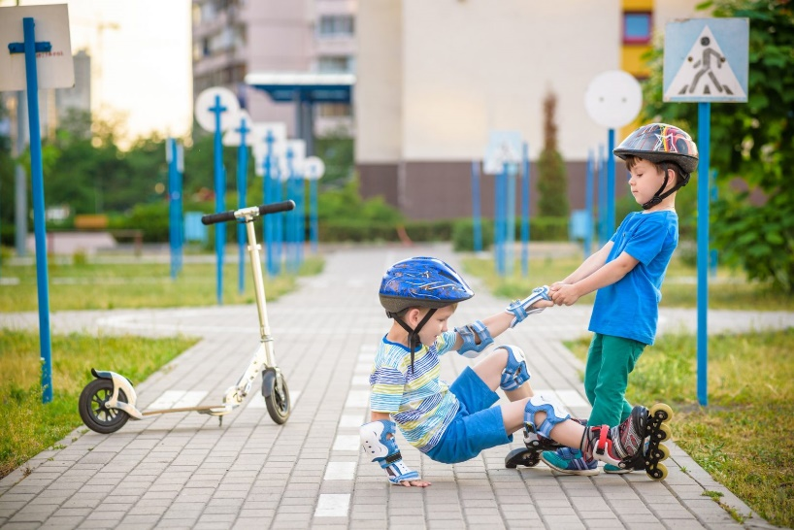
This week’s article continues with the theme of developing healthy and resilience children and can be found at www.psycom.net
All children are capable of working through challenges and coping with stress. Resilience is the ability to bounce back from stress, adversity, failure, challenges, or even trauma. It’s not something that kids either have or don’t have; it’s a skill that kids develop as they grow.
Resilient kids are more likely to take healthy risks because they don’t fear falling short of expectations. They are curious, brave, and trusting of their instincts. They know their limits and they push themselves to step outside of their comfort zones. This helps them reach for their long-term goals and it helps them solve problems independently.
Stress and Resilience
All kids encounter stress of varying degrees as they grow. Despite their best efforts, parents can’t protect kids from obstacles. Kids get sick, move to new neighbourhoods, encounter bullies and cyberbullies, take tests, cope with grief, lose friends, and deal with divorce, to name a few. These obstacles might seem small in the eyes of an adult, but they feel large and all-consuming to kids.
Resilience helps kids navigate these stressful situations. When kids have the skills and the confidence to confront and work through their problems, they learn that they have what it takes to confront difficult issues. The more they bounce back on their own, the more they internalize the message that they are strong and capable.
Strategies to Build Resilience
Parents can help kids build resilience and confront uncertainty by teaching them to solve problems independently. While the gut reaction of the parent might be to jump in and help so that the child avoids dealing with discomfort, this actually weakens resilience. Kids need to experience discomfort so that they can learn to work through it and develop their own problem-solving skills. Without this skill-set in place, kids will experience anxiety and shut down in the face of adversity.
Build a Strong Emotional Connection
Spend one-on-one time with your kids: Kids develop coping skills within the context of caring relationships, so it’s important to spend one-on-one time with them. This means you need to put down the smart phone and focus on your child. When kids know they have the unconditional support of a parent, family member, or even a teacher, they feel empowered to seek guidance and make attempts to work through difficult situations. Positive connections allow adults to model coping and problem-solving skills to children.
Promote Healthy Risk-Taking
In a world where playgrounds are made “safe” with bouncy floor materials and helicopter parenting, it’s important to encourage kids to take healthy risks. What’s a healthy risk? Something that pushes a child to go outside of their comfort zone, but results in very little harm if they are unsuccessful. Examples include trying a new sport, participating in the school play, or striking up a conversation with a shy peer. When kids avoid risk, they internalize the message that they aren’t strong enough to handle challenges. When kids embrace risks, they learn to push themselves.
Resist the Urge to Fix It and Ask Questions Instead
When kids come to parents to solve their problems, the natural response is to lecture or explain. A better strategy is to ask questions. By bouncing the problem back to the child with questions, the parent helps the child think through the issue and come up with solutions.
Teach Problem-Solving Skills
The goal is not to promote rugged self-reliance. We all need help sometimes, and it’s important for kids to know they have help. By brainstorming solutions with kids, parents engage in the process of solving problems. Encourage kids to come up with a list of ideas and weigh the pros and cons of each one.
Label Emotions
When stress kicks in, emotions run hot. Teach your kids that all feelings are important and that labelling their feelings can help them make sense of what they’re experiencing. Tell them it’s okay to feel anxious, sad, jealous, etc. and reassure them that bad feelings usually pass.
Demonstrate Coping Skills
Deep breathing exercises help kids relax and calm themselves when they experience stress or frustration. This enables them to remain calm and process the situation clearly.
Embrace Mistakes—Theirs and Yours
Failure avoiders lack resilience. In fact, failure avoiders tend to be highly anxious kids. When parents focus on end results, kids get caught up in the pass/fail cycle. They either succeed or they don’t. This causes risk avoidance. Embracing mistakes (your own included) helps promote a growth mindset and gives kids the message that mistakes help them learn. It can be helpful to talk about a mistake you made and how you recovered from it.
Promote the Bright Side—Every Experience Has One
Optimism and resiliency go hand in hand. Some kids may appear more naturally optimistic than others, but optimism can be nurtured. If you have a mini pessimist on your hands, acknowledge the feelings that lead to pessimistic thinking and teach your child to reframe his thoughts to find the positive.
Model Resiliency
The best way to teach resilience is to model it. We all encounter stressful situations. Use coping and calming strategies. Deep breathing can be an effective way to work through stress. Always label your emotions and talk through your problem-solving process.
Go Outside
Exercise helps strengthen the brain and make it more resilient to stress and adversity. While team sports are the most popular method of consistent exercise for kids, all kids really need is time spent outdoors engaging in a physical activity. If team sports don’t appeal to your child, encourage them or introduce them to bicycling, playing tag, or even just swinging at the playground. These are all great ways for kids to engage in free play that also builds resilience.
Resilience helps kids navigate the obstacles they encounter as they grow. It’s not possible to avoid stress, but being resilient is one of the best ways to cope with it.

