

This week we explore the benefits of mindfulness and specifically how it can build resilience in our lives and those of our children.
The following article can be found at www.psychcentral.com
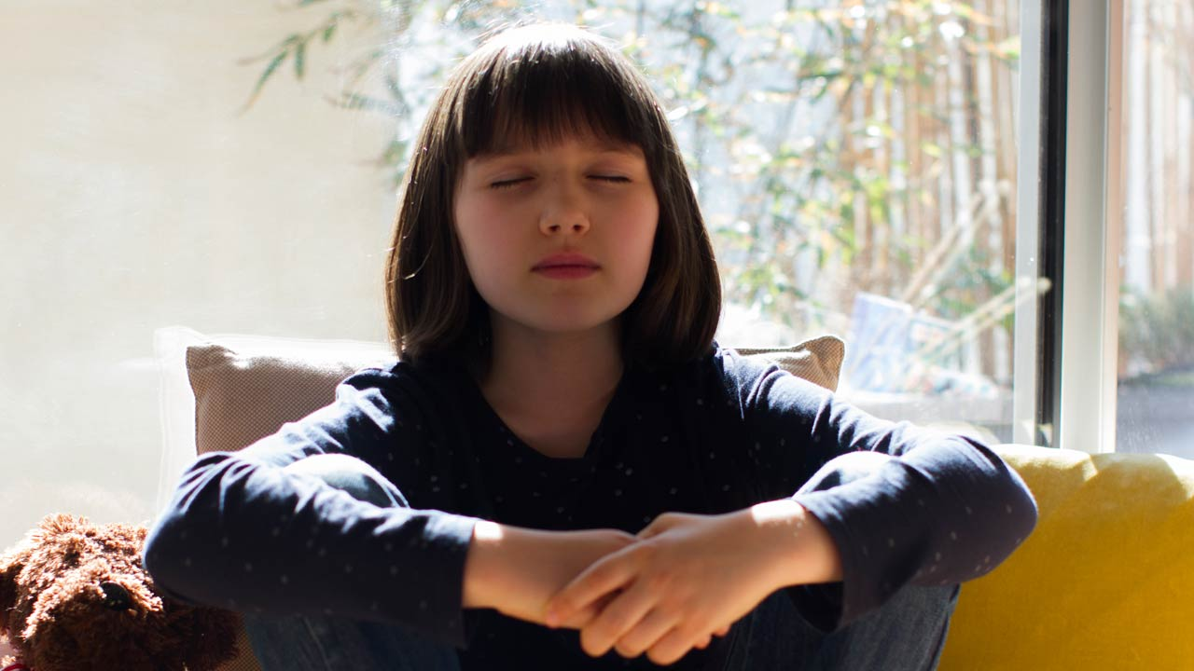
Mindfulness: The Art of Cultivating Resilience
Mindfulness practice has a variety of benefits. Helping you build resilience is one of the key benefits to developing a day-to-day mindfulness practice.
When dealing with stress or anxiety, it can be hard to cope. Your emotions may feel unmanageable or overwhelming.
Mental health conditions may make it hard to get through times of crisis or healthily handle stress. But mindful coping strategies are available to help you relax and find a state of peace in your life.
If you seek to become more self-aware and handle stress better, mindfulness practice may be something to consider.
How does mindfulness build resilience?
Mindfulness is about living in the present moment and being intentional. Resilience is defined as bouncing back from adverse life events or recovering quickly from difficulties.
Resilience also is related to the characteristics that allow you to thrive after an adverse event. Mindfulness and resilience often go hand and hand.
Research from 2021, evaluated the impact mindfulness-based practice and physical activity have on the development of resilience.
Findings indicated that mindfulness-based practice could lead to greater levels of individual resilience.
Types of resilience
There are various types of resilience. Understanding the four different types of resilience may be essential to building resilience.
- Physical resilience. The ability of your body to maintain stamina and face challenges while recovering quickly. Physical resilience often declines with age.
- Emotional resilience. The ability to regulate your emotions when faced with stressful or unexpected events.
- Mental resilience. The ability to handle crises and learn how to deal with challenges in your life.
- Social resilience. The ability of social systems to handle and recover from events such as political, social, and economic problems.
How do you build resilience?
5-4-3-2-1 Grounding techniques
Grounding techniques are one method of building resilience. Grounding techniques are a steady physical and emotional presence supported “by the ground”.
One grounding technique that is helpful for many is the 5-4-3-2-1 grounding technique. Consider taking time to notice your surroundings in the present moment by naming:
- 5 things you can see
- 4 things you can feel
- 3 things you can hear
- 2 things you can smell
- 1 thing you can taste
This calming technique can help you reduce anxiety and build emotional regulation skills.
Mindfulness meditation
Mindfulness meditation is supported in research as a method of resiliency training.
For example, a 2019 study Trusted Source that used a mindfulness meditation-based intervention compared the effects of a 4-day intensive meditation to a control group. Findings indicate that mindfulness meditation improved resilience up to three months after the intervention.
- Body scan meditation
The body scan meditation is a brief meditation that allows you to gain awareness of different body parts and the present sensations. Body scan meditation works by mentally tuning into awareness of your body from feet to head.
The purpose is to connect with your body and reduce stress. A large 2021 study Trusted Source found that this can be done virtually with mindfulness facilitators, effectively reducing stress and anxiety.
- Progressive muscle relaxation
Progressive muscle relaxation (PMR) is a technique that aims to relieve tension and stress in the body. It involves you tensing and relaxing each major muscle group from your feet to your head.
Research from 2021Trusted Source indicates that PMR can alleviate stress, provide a more relaxed state, and improve overall well-being.
Using this technique can help you build resilience to stress in the future. Another review suggests cognitive behavioural therapy for insomnia, which includes muscle relaxation, can help you fall asleep, and it has shown positive effects on individuals with insomnia.
- Mindful breathing exercises
Deep breathing exercises are another way you can reduce stress. There are many different breathing techniques; many involve breathing through your nose, holding your breath, and exhaling.
How long you hold your breath is dependent on the type of breathing exercise you do.
Research Trusted Source that examined the impact of a six-week deep breathing practice daily for a short duration suggests that deep breathing techniques can improve cognitive processes.
I would encourage parents and care givers to practice these exercises with their children regularly (perhaps in bed prior to going to sleep) so they are familiar and easier to implement when needed. As mentioned last week the Smiling Mind app has great body scan meditations to help children develop the awareness of what’s happening in their bodies.

